**PROJECT REPORT**

Zomato Data Analysis

**Name** – Shaikh Aman Hashim

**Project Title** – Zomato Data Analysis

**Date** – 13 Jan 2025

**Technology** – Power Bi

**Tools-** Power BI Visualization Tools

### **Project Description:**

This project involves the analysis of Zomato's dataset to uncover key insights about restaurant trends, customer preferences, and business performance. By leveraging the powerful data visualization capabilities of Power BI, this project provides actionable insights for stakeholders such as restaurant owners, food enthusiasts, and business analysts.

### **Objectives:**

* **Understand Restaurant Trends**: Analyze the distribution of restaurants across cities, cuisines, and ratings.
* **Customer Insights**: Identify customer preferences based on reviews, ratings, and pricing.
* **Market Analysis**: Compare restaurants by type (e.g., dine-in, delivery) and price range.
* **Business Growth Opportunities**: Highlight top-performing locations and cuisines for business expansion.

### **Key Performance Indicators (KPIs):**

The dashboard tracks the following KPIs to measure the performance of Zomato Data Analysis.

#### **1.** Total Restaurants**:**

* **Value:** 9,545
* **Relevance:** The total number of restaurants is a key indicator of the dataset's scope and coverage..
* **Observation:** The dataset reveals a significant presence of restaurants across 141 cities and 15 countries, indicating Zomato's extensive market reach.

#### **2.** Countries Covered Analysis**:**

* **Value:** 15
* **Relevance:** The number of countries provides insights into Zomato's global footprint and market penetration.
* **Observation:** The dataset covers 15 countries, showcasing Zomato's broad reach and influence in the food and restaurant industry globally...

#### **3.** Total Cities Analyzed**:**

* **Value:** 141.
* **Relevance:** The number of cities analyzed highlights Zomato's extensive urban reach and market coverage within and across countries..
* **Observation:** The dataset spans 141 cities, indicating a strong presence in both major metropolitan hubs and smaller cities.

#### **4.** Total Customer Votes:

* **Value:** 3.75M
* **Relevance:** The number of customer votes is a critical indicator of customer engagement and feedback on the platform.
* **Obervation:** A total of 3.75 million votes demonstrates a strong level of customer engagement, showcasing Zomato's ability to attract and retain active users.

#### **5.** Maximum Average Cost for Two:

* **Value:** 2M

#### **6.** Rating Distribution:

* Excellent: 3.15%.
* Very Good: 39.13%.
* Good: 22.48%.
* Average: 21.98%.
* Poor: 1.95%..

### **Data Summary:**

The dataset includes:

* **Dataset Highlights**:**:**
* **Restaurant Information**: Includes names, locations, and service types.
* **Cuisines**: Wide variety, with North Indian and Chinese being the most common.
* **Cost for Two**: Captures the pricing range, highlighting affordability and premium segments.
* **Customer Feedback**: Ratings and votes provide insight into customer satisfaction.
* **Data Cleaning and Preparation:**
* Removed duplicate entries and standardized data formats.
* Handled missing values for critical columns such as ratings and votes.
* Created calculated fields for metrics like average ratings and total reviews.

### **Analysis and Findings:**

#### **1] Total Restourants by City:**

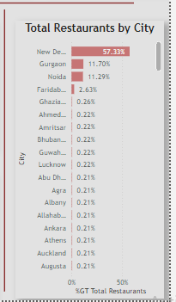

* **Visualization:** This chart displays the percentage of total restaurants by city, with New Delhi contributing the highest percentage at 57.33%, followed by Gurgaon (11.70%) and Noida (11.29%). Smaller percentages are distributed among other cities.
* **Observation:**
  + 1. Dominance of New Delhi: More than half of the total restaurants are located in New Delhi, showing a significant concentration..
  + 2. Significant Contribution by NCR: Cities in the National Capital Region (NCR) such as Gurgaon and Noida collectively account for a substantial portion.

#### **2] Votes by Rating text:**

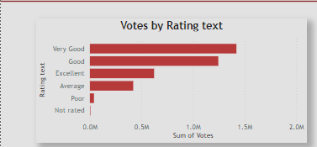

* **Visualization: The chart represents the sum of votes based on different rating categories, indicating customer sentiment.**
* **Observation:**
* **1. "Very Good" Leads: The highest number of votes fall under the "Very Good" category, suggesting a generally positive sentiment among customers.**
* **2. "Good" and "Excellent" Follow: These categories also receive substantial votes, with "Good" slightly surpassing "Excellent."**
* **3. Lower Votes for Negative Ratings: "Average" and "Poor" ratings have significantly fewer votes, indicating that most customers are either satisfied or highly satisfied.**
* **4. Negligible for "Not Rated": The "Not Rated" category has the least votes, likely due to limited feedback without a specific rating.**

#### **3] Total restourants By Rating:**

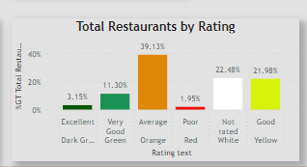

* **Visualization: This Column chart representing restaurant data based on their ratings.**
* **Observation:**
* **Average is the most common rating:** With 39.12%, most restaurants fall into the average category.
* **Good and Not Rated follow:** Good restaurants make up 21.98%, while 22.48% of restaurants are not rated.
* **Very Good is less frequent:** Only 11.3% of restaurants achieve a very good rating.
* **Poor ratings are rare:** A tiny 1.95% of restaurants receive poor ratings.
* **Excellent is the least common:** Only 3.15% of restaurants manage to get an excellent rating

#### **4] Total Restourants by Cuisines:**

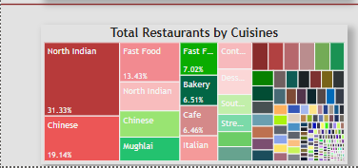

* **Visualization:** **The treemap effectively displays the hierarchical structure of the data, with the size of each rectangle representing the proportion of restaurants offering a specific cuisine.**
* **Observation:**
* **North Indian cuisine:** dominates the market with the highest percentage of restaurants (31.33%).
* **Chinese cuisine:** follows as the second most popular, holding a significant share of the market (19.14%).
* **Fast Food:** and Mughlai cuisines also have a notable presence, though smaller than the top two.
* Bakery, Cafe, and Italian cuisines have a smaller market share compared to the others.
* The remaining cuisines, represented by smaller rectangles, collectively account for a considerable portion of the market.

#### **5] Total Restourants By City:**

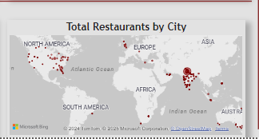

* **Visualization:** This map showcases the distribution of restaurants listed on Zomato across the globe.
* **Observation:**
  + **Concentration:**
    - The map clearly shows a higher concentration of restaurants in North America, Europe, and parts of Asia, particularly India and Southeast Asia.
  + **Sparse Areas:**
    - Africa, South America, and Australia have noticeably fewer restaurants listed on Zomato.
  + **Urban Centers:**
    - The red dots, which represent restaurants, are clustered around major cities, highlighting the urban-centric nature of restaurant listings.
  + **Data Gaps:**
    - The map might not accurately reflect the total number of restaurants in each region, but rather the extent of Zomato's coverage and data collection in those areas.

### **Details Dashboard Analysis:**

* **KPI Cards**: Highlighting critical metrics like total restaurants, countries, cities, and customer votes.
* **Visuals**:
* Bar charts showing the distribution of ratings and votes.
* Heatmaps and geographic maps illustrating restaurant density across regions.
* Tree maps displaying cuisine distribution by popularity.
* **Filters**: Enable dynamic analysis based on delivery availability, price range, and location.

**SnapShpot:**

**DashBoard :**

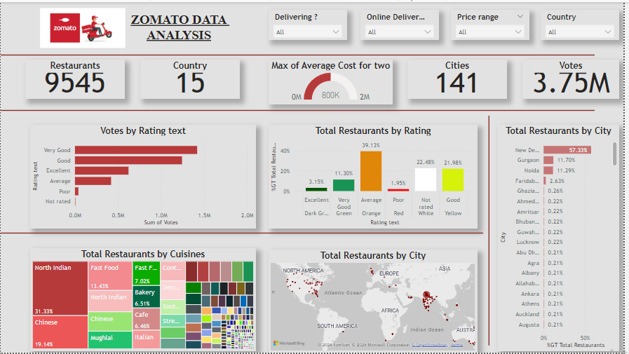

### **Recommendations:**

• **Enhance Customer Experience**:

* Focus on improving service and quality in restaurants with "Average" and "Poor" ratings.
* Introduce loyalty programs to encourage repeat visits.

• **Expand Popular Cuisines**:

* Increase availability of North Indian and Chinese cuisines in underrepresented areas.
* Explore growth opportunities for emerging cuisines like Mughlai and Italian.

• **Strengthen Delivery Services**:

* Promote delivery services in regions with growing demand.
* Offer discounts and deals to attract more online orders.

• **Target Key Markets**:

* Focus marketing efforts on top-performing cities like New Delhi, Gurgaon, and Noida.
* Identify underserved cities for potential expansion.

• **Optimize Pricing**:

* Cater to the moderate price range, which aligns with higher customer satisfaction.
* Experiment with premium pricing for niche cuisines and high-quality services.

### **Conclusion:**

highlights critical trends in customer preferences, restaurant performance, and market dynamics. By leveraging these insights, stakeholders can:

* Enhance service quality and customer satisfaction.
* Optimize pricing and delivery strategies.
* Expand operations into high-demand markets.
* Diversify offerings to attract a broader customer base.

This project demonstrates the value of data-driven decision-making in the competitive food and restaurant industry.